**LAB 10**

**2019F_ESE 3014_1**

**GROUP 16 -**

**FRANCIS VIJITH A J– C0742980**

**VIJAYAPRAKASH V I – C0744450**

**INTERFACING-COMMUNICATION UART BETWEEN ARDUINO UNO AND BEAGLEBONE BLACK**

**Checking for available UART devices**

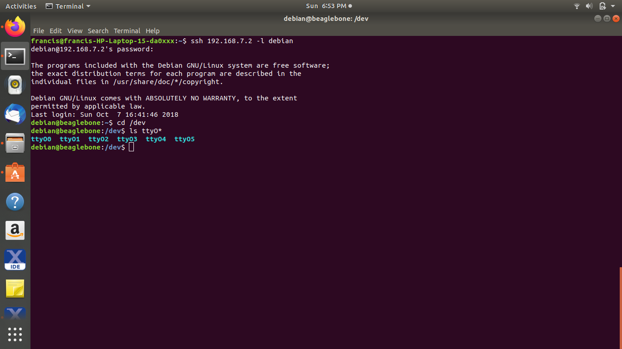

**Checking for working of UART devices(echoing a key back when pressed, to the console) by enabling the local echo and bridging the RX and TX pins of Beaglebone black.**

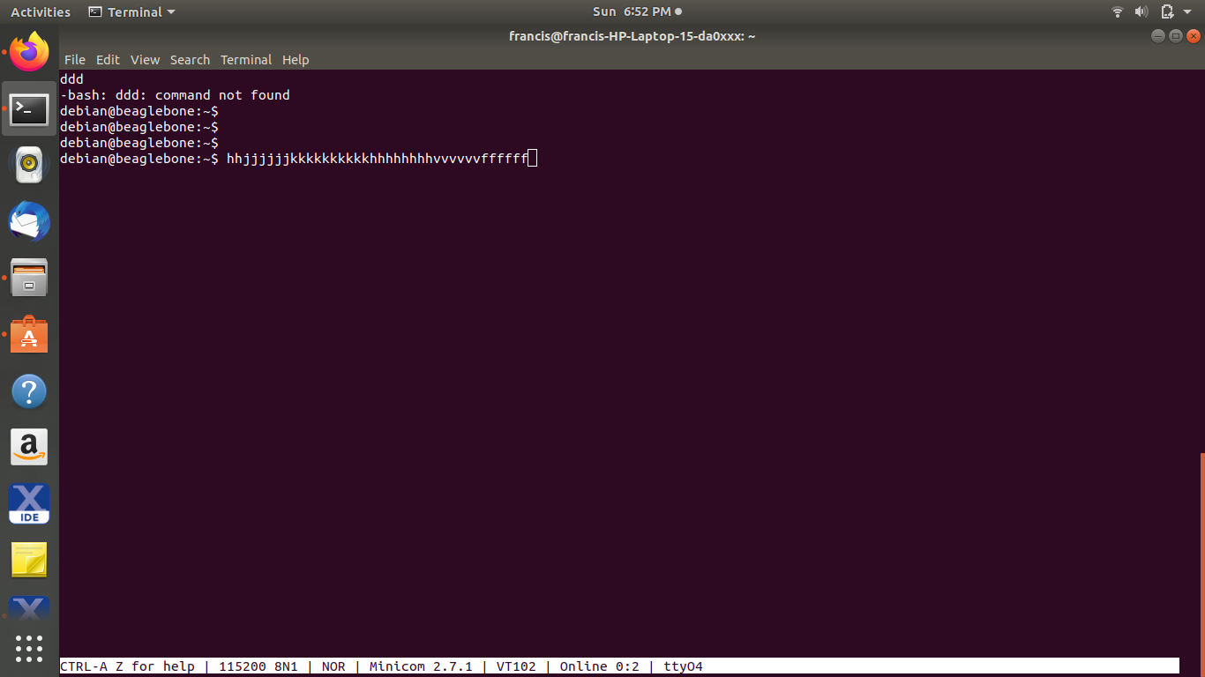

Working video URL: https://www.youtube.com/watch?v=GJlQCLPWXoI

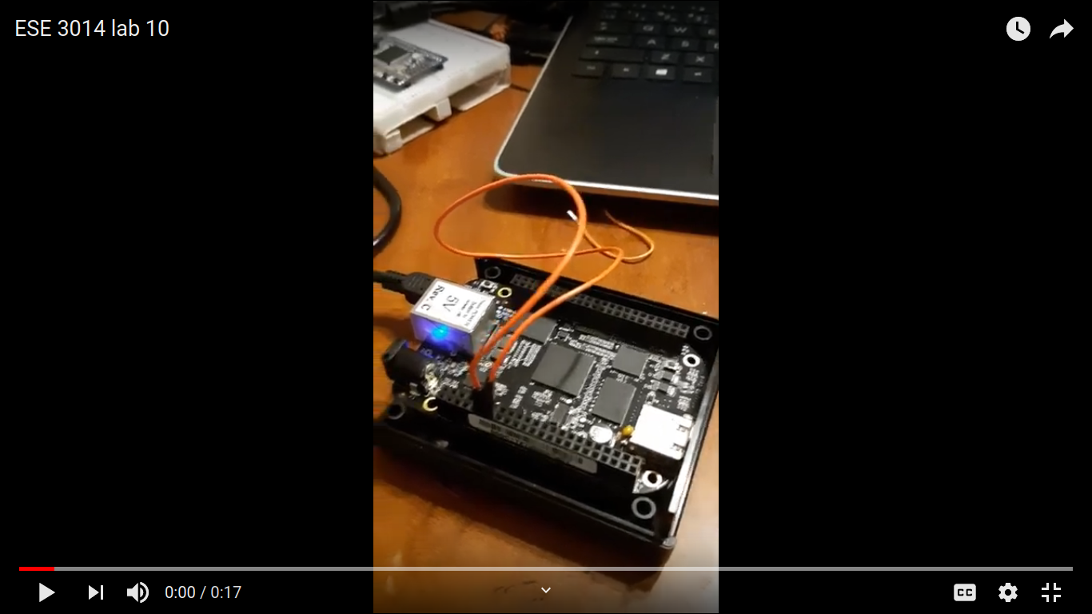

image 1: bridging RX and TX pins.

**Testing the arduino IDE serial monitor and BB minicom for serial communication**

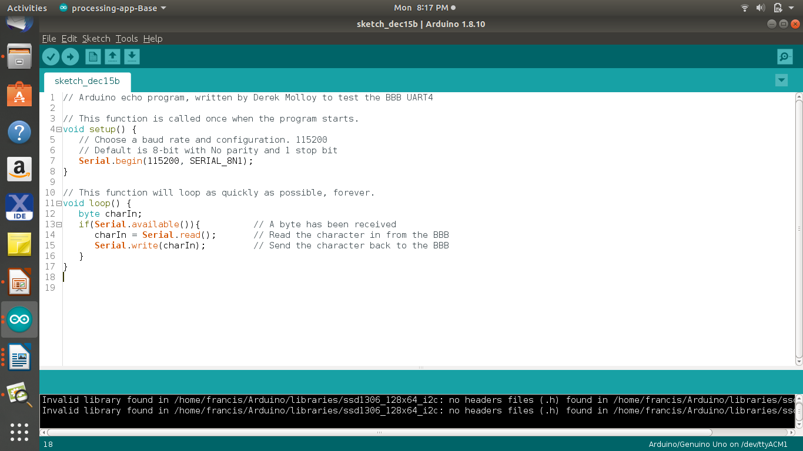image two: Basic arduino serial program.

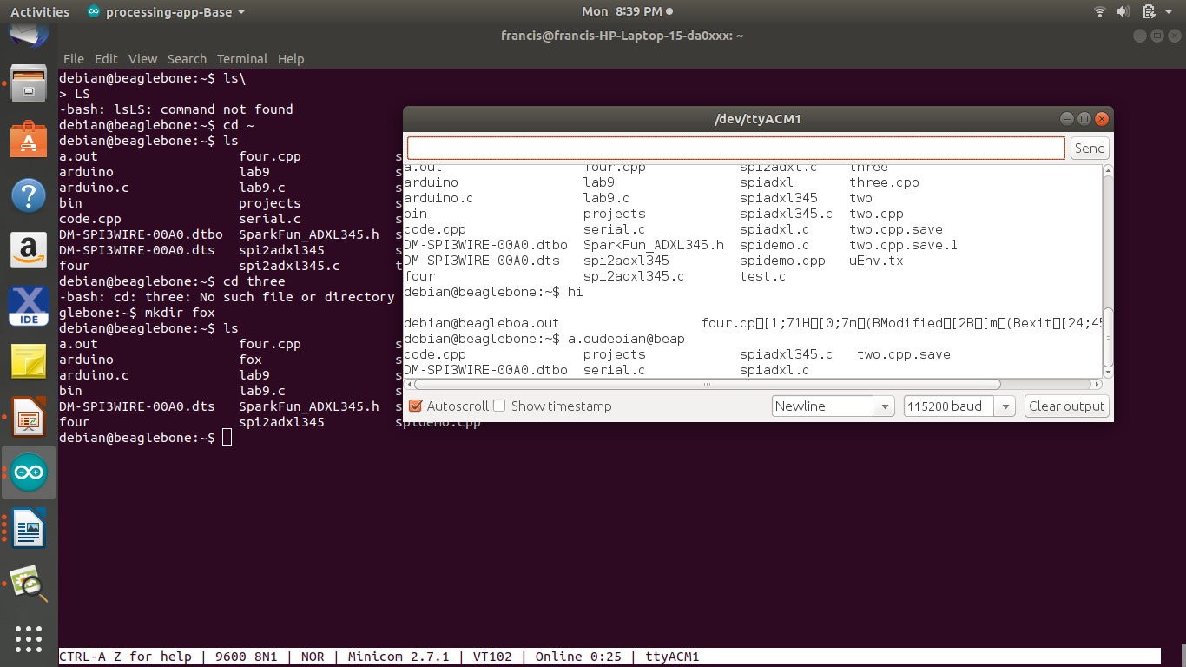

Working video URL: <https://www.youtube.com/watch?v=Mdb16WCZauI>

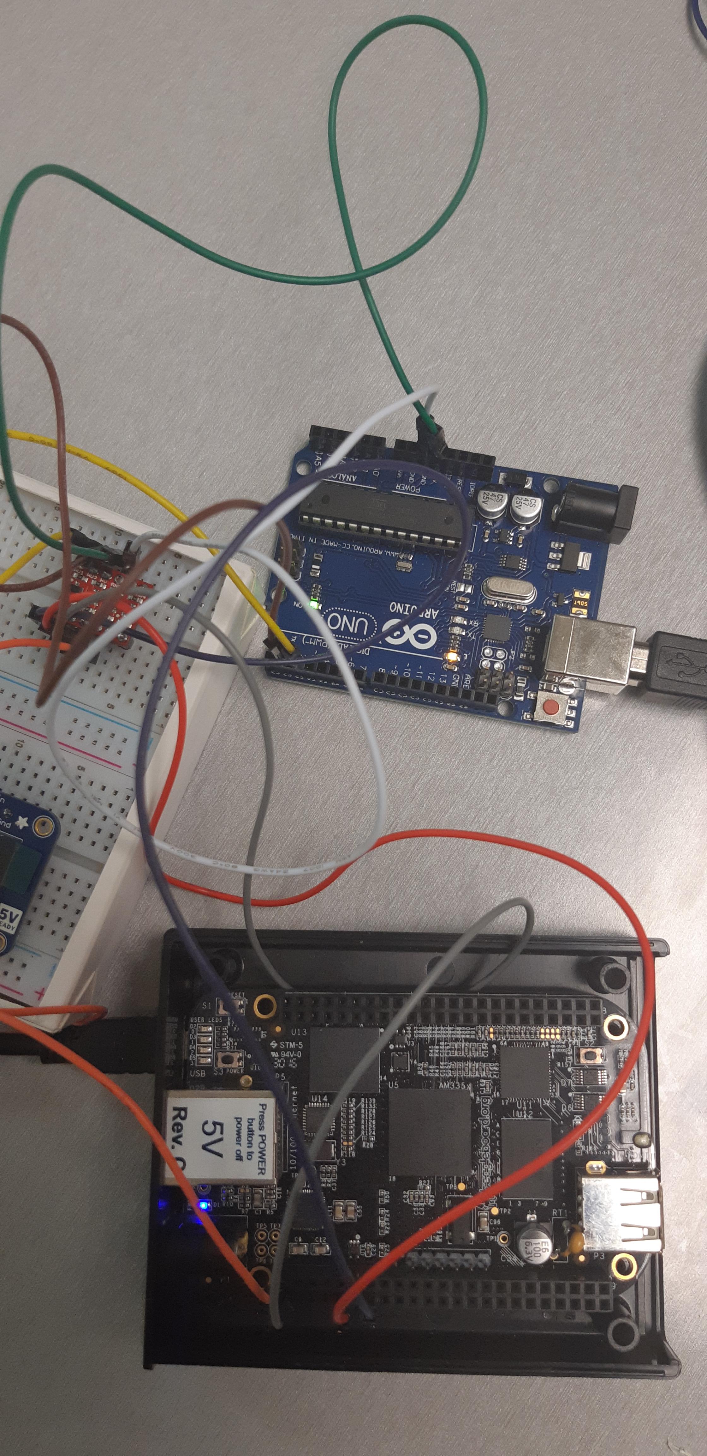

image three: circuit connection